6A^{th} Grade: Unit 6, Lesson 3

- How many integer chips would be needed to add to -4 to result in a zero pair?

4 positive integer chips

- Write an expression that represents the integer chips shown.
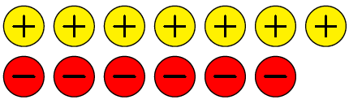

7 + (-6)

- Use integer chips to represent the expression 4 + (-6).
